LISTENINGS . NAME______________________________
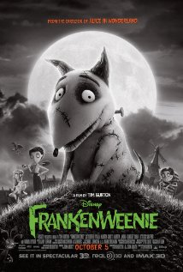
http://www.youtube.com/watch?v=XBfcGLBJ2Uc

1.-What´s the name of the dog?
2.-The dog is playing with …
a.-a car
b.-a ball
c.-a toy
3.-Victor was sad because the dog…
a.-was dead
b.-was alive
c.-was happy
4.-At the end, the dog….
a.-was dead
b.-was alive
c.-was sad

http://www.youtube.com/watch?feature=player_embedded&v=C05pGnZQQtE
1.-Where are Alex, Marty,Melman and Gloria?
a.-On the beach
b.-In the sea
c,.On a boat
d.-In the zoo
2.-Where are the penguins?
a.-In a car
b.-On a boat
c.-In the casino
d.-On the beach
3.-What do the penguins throw through the window?
a.-Food
b.-An animal
c.-A TV
d.-A box
4.-What do the penguins fight with?
a.-Chairs
b.-Guns
c.-Pillows
d.-Beds

LISTENING
http://www.youtube.com/watch2Uc

Frankenweenie Trailer
1.-

MADAGASCAR
5.-How do the people feel when the gang comes into the casino through the roof?
a.-cross
b.-dizzy
c.-thirsty
d.-scared
6.-Who chases them?
a.-A policewoman
b.-A zoo keeper
c.-The army
d.-A firefighter
7.-How do they chase them?
a.-By bicycle
b.-By motorbike
c.-On foot
d.-By plane
8.-What do they find?
a.-A zoo
b.-A theatre
c.-A circus
d.-A treasure
9.-What does Marty put on?
a.-A cap
b.-A hat
c.-A jacket
d.-A wig

