Snowflake .NAME________
♫ Snowflake, snowflake
little snowflake.
Little snowflake
falling from the sky.
Snowflake, snowflake, little snowflake.
Falling, falling, falling, falling, falling,
falling, falling, falling, falling...
falling on my head.
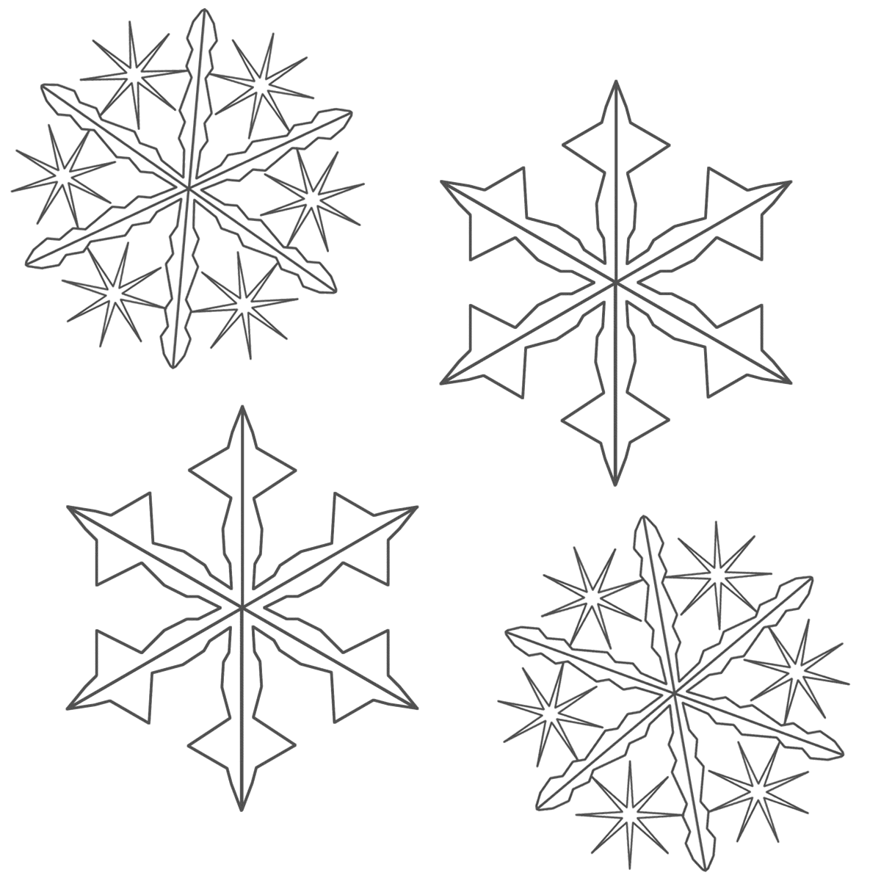
Snowflake, snowflake, little snowflake.
Little snowflake falling from the sky.
Snowflake, snowflake, little snowflake.
Falling, falling, falling, falling, falling,
falling, falling, falling, falling...
falling on my nose.
Snowflake, snowflake, little snowflake.
Little snowflake falling from the sky.
Snowflake, snowflake, little snowflake.
Falling, falling, falling, falling, falling,
falling, falling, falling, falling...
falling in my hand.
Falling on my head.
Falling on my nose.
Falling in my hand.
Snowflake, snowflake, little snowflake... ♫
SKY | SNOWFLAKE | SNOWFLAKE
HEAD | NOSE | HANDS

